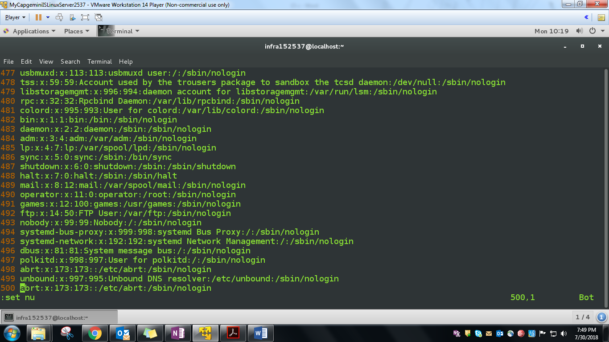

* Used yy and p option to create 500 random data lines